in silico investigation of the potential inhibitory effects of anthraquinone derivatives on alpha synuclein aggregation
s. draga*#,**, EMILIA BUŞE**, SPERANŢA AVRAM*
*Department of Anatomy, Animal Physiology and Biophysics, Faculty of Biology, University of Bucharest, Bucharest,, Romania, #e-mail: sor.draga@gmail.com
** S.C. Biotehnos S.A., 3−5 Gorunului Street, 075100-Otopeni, Ilfov, Romania
Abstract. Parkinson’s disease and Lewy body dementias are progressive neurodegenerative diseases accompanied by dementia and a wide array of symptoms such as bradykinesia, rigidity and postural instability. The hallmark of the disease is alpha synuclein aggregation, leading to the formation of Lewy. In this paper we investigate, using various in silico tools, the potential anti-aggregation effects of anthraquinone derivatives carminic, kermesic and laccaic acid and their potential future use as lead compounds for clinical applications. To this end, we employed a combination of predictors used for properties like absorption, distribution, metabolism and excretion (ADME), drug-likeness and lead-likeness. Additionally, we used a molecular docking to estimate the binding affinities of the three compounds to alpha synuclein. Our predictions indicate kermesic acid as the compound having the greatest therapeutical potential.
Key words: Parkinson’s disease, alpha synuclein, carminic acid, kermesic acid.
introduction
Parkinson’s Disease and Lewy body dementias are progressive neurodegenerative diseases accompanied by dementia and a wide array of symptoms such as bradykinesia, rigidity and postural instability, among others. The main cause of the disease is considered to be the death of dopaminergic neurons in the substantia nigra with direct involvement of the alpha synuclein protein.
On a molecular level, neuronal death is driven by the accumulation and aggregation of the presynaptic protein alpha synuclein from the cytosol and possible low-affinity binding to neuronal membranes, leading to a loss of conformational entropy and leading to a more structured helical form that facilitates membrane interaction [5], pore formation [8] and subsequent genesis of Lewy bodies, abnormal intraneuronal accumulations of proteins, driven by its aggregation but also containing numerous other proteins responsible with ubiquitination and protein trafficking, oxidative stress, chaperones, kinases and many others. Structurally, alpha synuclein is a 140 aminoacid long intrinsically unstructured presynaptic protein and may suffer a series of post-traslational modifications as oxidation, nitrosylation, phosphorylation, glycation and glycosylation [16].
Structurally, alpha synuclein is divided into three main domains: the amphipathic N-terminus region, comprised of aminoacids 1−60 and containing numerous sites responsible for membrane binding, the hydrophobic NAC (non-amyloid-β component) region, comprised of aminoacids 61−95 and considered to be the main driver of protein aggregation [1] and an acidic intrinsically unstructured C-terminus tail involved in the inhibition of aggregation [4].
A number of highly conserved KTKEGV motif imperfect repeats are located in the N-terminus [13], with the KTKEGV motif itself [2] involved in the protein’s tetramerization and the reduction of neurotoxicity.
Recently, a seven residue sequence (aminoacids 36−42) linker region was identified by Brockwell’s group [3] that appears to control the aggregation behavior of alpha synuclein. A wide range of aggregation inhibitors have been identified by high throughput screening for the alpha synuclein monomer [7] mainly targeting the NAC region.
Carminic acid was recently shown to inhibit aggregation of human serum albumin [15]. In the present study, using various in silico methods, our aims are: (1) to evaluate the binding affinities of anthraquinone derivatives carminic, laccaic and kermesic acid on alpha synuclein using a blind molecular docking approach, (2) to evaluate the ADME (absorption, distribution, metabolism, excretion) profile of carminic, kermesic and laccaic acid, and (3) to evaluate the drug-likeness of the given molecules.
materials and methods
The structures of the anthraquinone derivatives carminic acid, kermesic acid and laccaic acid were downloaded from the PubChem database [11] in SDF (Spatial Data File) format. The files were then converted to the PDB (Protein Data Bank) and SMILES (Simplified Molecular Input Line Entry System) format using the online OpenBabel conversion tools [10].
The structure of human alpha synuclein, covering the full sequence of the protein (PDB ID: 1XQ8) was downloaded from the Protein Data Bank [14] and the first (lowest energy) NMR conformer was used in the subsequent docking runs.
Further, the generated files were visually inspected for potential structural errors and minimized using Swiss PDB Viewer version 4.1 [6] to remove any possible geometrical imperfections resulting from the conversion, and both protein and ligand files were submitted to MGL Tools version 1.5.7.rc1. Docking runs were performed using Autodock Vina version 1.1.2 [12], using standard docking parameters (exhaustiveness = 8, number of generated hits = 9). The generated files were visualized with PyMOL Molecular Graphics System, Version 1.7.4, Schrödinger, LLC, New York, and interaction diagrams were obtained using LigPlot+ [9].
Table 1
Anthraquinone derivates, with corresponding chemical structures and SMILES codes

Name | Structure | SMILES code
Carminic acid | 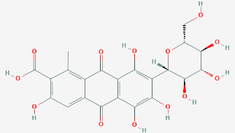 | CC1=C2C(=CC(=C1C(=O)O)O)C(=O)C3=C(C2=O)C(=C(C(=C3O)O)C4C(C(C(C(O4)CO)O)O)O)O
Kermesic acid | 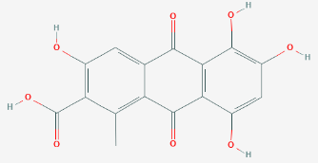 | CC1=C2C(=CC(=C1C(=O)O)O)C(=O)C3=C(C2=O)C(=CC(=C3O)O)O
Laccaic acid | 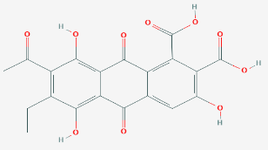 | CCC1=C(C(=C2C(=C1O)C(=O)C3=CC(=C(C(=C3C2=O)C(=O)O)C(=O)O)O)O)C(=O)C

Further, we used the SwissADME web server [17] to evaluate the absorption, distribution, metabolism and excretion profile along with drug and lead likeness, by providing the corresponding canonical SMILES codes for each of the three molecules of interest (Table 1).
RESULTS AND DISCUSSION
Our results show that carminic acid, along with kermesic and laccaic acid bind the linker region with high affinities (Table 2, 3 and 4 below), with carminic acid showing the highest affinity, followed by kermesic and laccaic acid, showing comparable binding affinities. Our results indicate that the interaction of carminic acid is stabilized by multiple hydrophobic contacts (for example with Gly41, Lys43, Glu35, Gly36, Tyr39) and two hydrogen bonds formed with aminoacids Lys32 and Val40 (as shown in Figure 1).
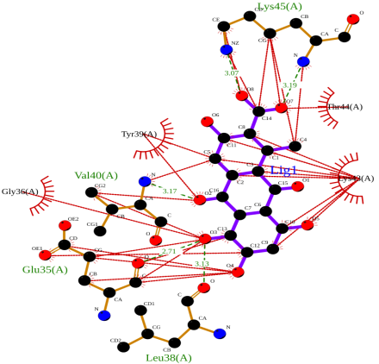
Table 2
Carminic acid binding affinities

Mode | Affinity  (kcal/mol) | Distance from best mode
 |  | RMSD l.b. | RMSD u.b.
1 | −7.9 | 0 | 0
2 | −6.8 | 2.689 | 4.659
3 | −6.4 | 2.987 | 9.841
4 | −6.4 | 4.21 | 7.194
5 | −6.3 | 1.906 | 4.059
6 | −5.8 | 24.292 | 27.946
7 | −5.8 | 3.218 | 5.918
8 | −5.7 | 45.26 | 50.307
9 | −5.7 | 71.798 | 76.645

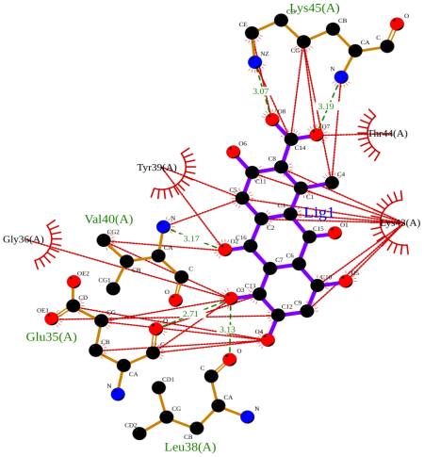
Fig. 1. Representation of carminic acid interaction with alpha synuclein.
Table 3
Kermesic acid binding affinities
Mode | Affinity  (kcal/mol) | Distance from best mode
 |  | RMSD l.b. | RMSD u.b.
1 | −6.5 | 0 | 0
2 | −6.2 | 2.015 | 2.712
3 | −6.2 | 2.159 | 6.879
4 | −6.1 | 1.416 | 6.324
5 | −5.5 | 2.722 | 5.349
6 | −5.3 | 3.307 | 7.378
7 | −5.2 | 4.006 | 5.643
8 | −5.2 | 4.778 | 8.978
9 | −5.1 | 72.033 | 75.526

Fig. 2. Representation of kermesic acid interaction with alpha synuclein.
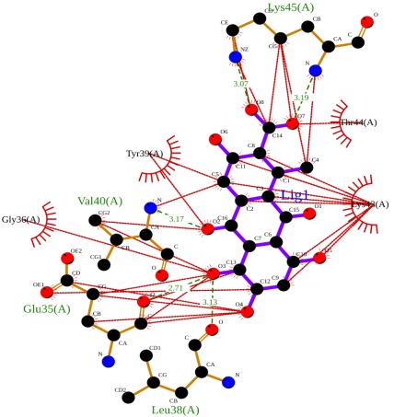
Table 4
Laccaic acid binding affinities
Mode | Affinity  (kcal/mol) | Distance from best mode
 |  | RMSD l.b. | RMSD u.b.
1 | −6.5 | 0 | 0
2 | −6.2 | 2.015 | 2.712
3 | −6.2 | 2.159 | 6.879
4 | −6.1 | 1.416 | 6.324
5 | −5.5 | 2.722 | 5.349
6 | −5.3 | 3.307 | 7.378
7 | −5.2 | 4.006 | 5.643
8 | −5.2 | 4.778 | 8.978
9 | −5.1 | 72.033 | 75.526

Fig. 3. Representation of kermesic acid interaction with alpha synuclein.
In the case of kermesic acid, the interaction is mediated by multiple hydrophobic contacts (for example with aminoacids Gly36, Gly41) and a hydrogen bond formed with Val40 (shown in Figure 2).
Laccaic acid forms hydrogen bonds with aminoacids Val40 and Lys32 and numerous hydrophobic interactions with adjacent residues (for example Gly41, Tyr39) as shown in Figure 3.
ADME EVALUATION OF CARMINIC ACID
In the case of carminic acid, the partition coefficient (logP) calculations consensus show a negative value, indicating the compound is not lipophilic. Our analysis shows that it has moderate water solubility with low gastro-intestinal absorption and does not permeate the blood-brain-barrier.
Carminic acid is not an inhibitor of the cytochrome P450 enzymes and is predicted as a possible P-glycoprotein 1 substrate. The molecule is not drug-like according to the full set of five predictors used by the SwissADME web-server. Carminic acid is also predicted to be a member of the pan-assay interference compounds class (PAINS), chemical compounds that have a high chance of giving a false positive result in high-throughput screening campaigns by reacting non-specifically with a wide range of biological targets. The compound shows an average synthetic accessibility of 5 (on a scale of 1 to 10, where 1 is easily accessible and 10 is difficult) and is not predicted to be lead-like (Fig. 4).
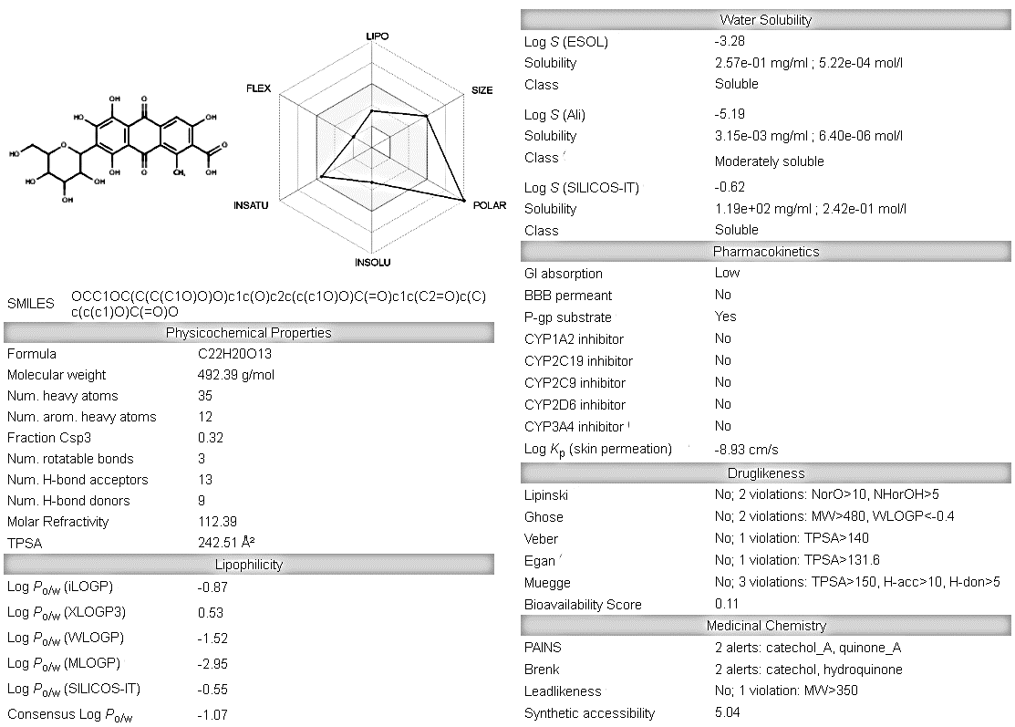

Fig. 4. Various predicted properties for carminic acid (general physicochemical properties, lipophilicity, water solubility, pharmacokinetics, drug-likeness and medicinal chemistry characterization), provided by the SwissADME web-server.
ADME EVALUATION OF KERMESIC ACID
In the case of kermesic acid, logP calculations consensus show a positive value, indicating that the compound is lipophilic. Our analysis shows that it has moderate water solubility, with low gastro-intestinal absorption and does not permeate the blood-brain-barrier. Also, kermesic acid is not an inhibitor of the cytochrome P450 enzymes and is not a possible P-glycoprotein 1 substrate. The molecule is drug-like according to two out of the five predictors used by the SwissADME webserver.
Kermesic acid is also predicted to be a member of the pan-assay interference compounds class (PAINS), chemical compounds that have a high chance of giving a false positive result in high-throughput screening campaigns by reacting non-specifically with a wide range of biological targets. Importantly, the compound shows high synthetic accessibility of 2.79 (on a scale of 1 to 10, where 1 is easily accessible and 10 is difficult) and is predicted to be lead-like (Fig. 5).
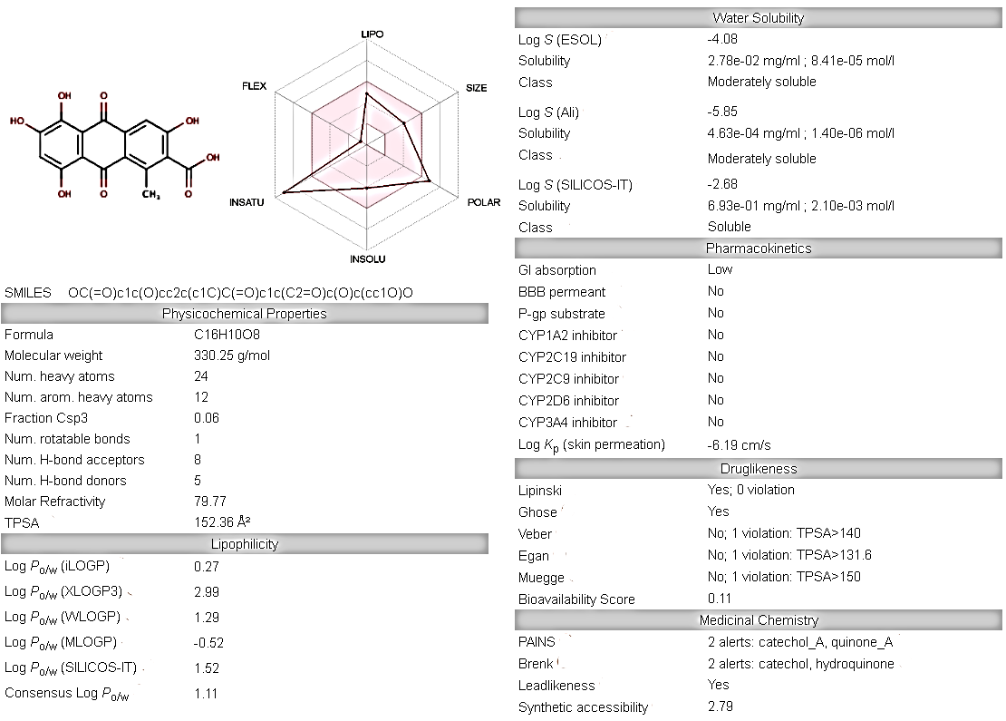

Fig. 5. Various predicted properties for kermesic acid (general physicochemical properties, lipophilicity, water solubility, pharmacokinetics, drug-likeness and medicinal chemistry characterization), generated by the SwissADME web-server.
ADME EVALUATION OF LACCAIC ACID
In the case of laccaic acid, logP calculations consensus show a positive value of 1.33, indicating that the compound is lipophilic. It has poor gastro-intestinal absorption and low water solubility, with no permeation of the blood-brain-barrier and is not an inhibitor of the cytochrome P450 enzymes and is not a possible P-glycoprotein 1 substrate. The molecule is drug-like according to according to two out of the five predictors used by the SwissADME webserver. Laccaic acid is also predicted to be a member of the pan-assay interference compounds class (PAINS), chemical compounds that have a high chance of giving a false positive result in high-throughput screening campaigns by reacting non-specifically with a wide range of biological targets. The compound shows high synthetic accessibility of 3.22 (on a scale of 1 to 10, where 1 is easily accessible and 10 is difficult) and is not predicted to be lead-like (Fig. 6).
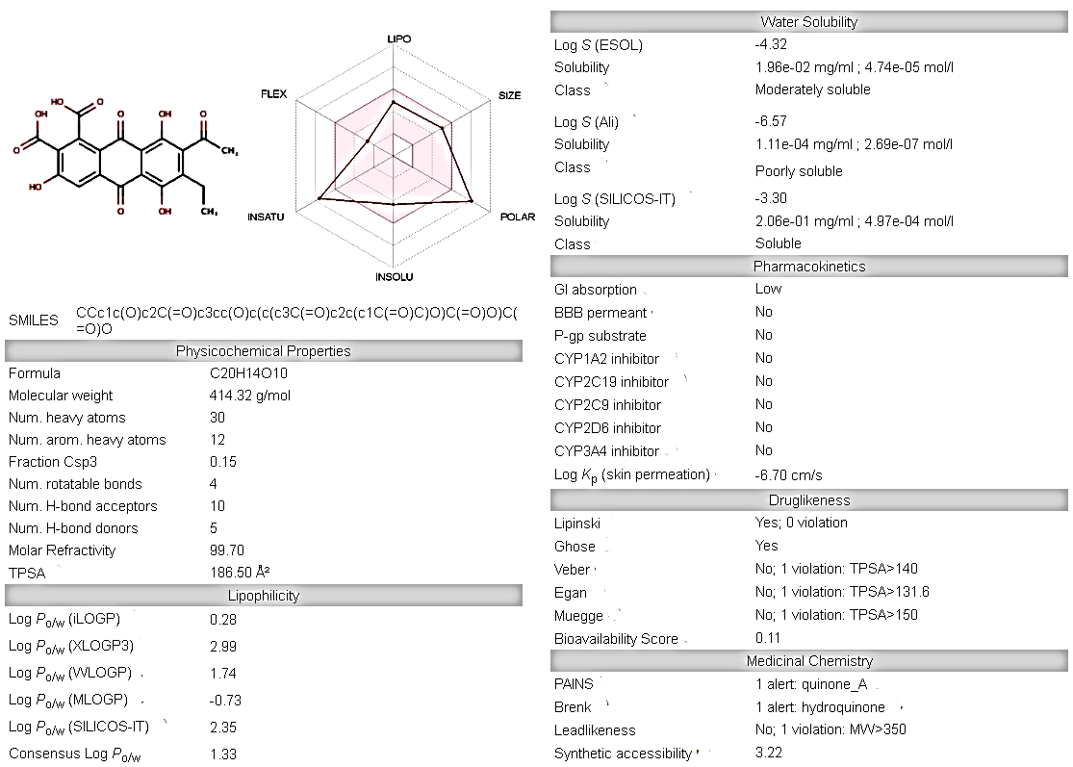

Fig. 6. Various predicted properties for laccaic acid (general physicochemical properties, lipophilicity, water solubility, pharmacokinetics, drug-likeness and medicinal chemistry characterization), generated by the SwissADME web-server.
Our predictions cover a number of important molecular characteristics, spanning lipophilicity and water solubility, which influence both gastro-intestinal (G.I.) absorption and cell membrane penetration of the evaluated compounds, various pharmacokinetic parameters such as the affinity for the cytochrome P complex, essential for drug metabolism and possible drug-drug interaction and blood-brain-barrier penetration (B.B.B.), which is especially relevant in the case of pharmacological intervention in neuronal pathologies. We also evaluate drug-likeness – the similarity between our compounds and other compounds already classified as drugs. Finally, we evaluate the possibility of our compounds could interfere with various assays (PAINS-pan-assay interference compounds), their lead- likeness – the probability of the compounds to have therapeutic value, but with suboptimal structural characteristics, that may require further optimization and their synthetic accessibility, an indication of how facile the compounds can be obtained by synthetic chemistry routes.
Considering our results, we can conclude that kermesic acid is the most promising molecule that can be used for the inhibition of alpha synuclein aggregation with potential clinical benefit – it shows the most promising ADME profile out of the three investigated candidates, with the highest logP, no affinity to cytochrome P450 and is not a P-glycoprotein 1 substrate. It also has excellent synthetic accessibility and is shown to be both drug and lead-like. Also, considering that all three molecules investigated in the present study show no blood-brain-barrier penetration, which would be paramount for their potential clinical applications, the fact that kermesic acid shows lead-like properties is very important, as it would most likely require additional structural optimization.
CONCLUSIONS
Our in silico investigation shows that kermesic acid, an anthraquinone derivative, has good potential for the inhibition of alpha synuclein aggregation, a hallmark of Parkinson’s disease. Further, we show that kermesic acid has an advantageous absorption, distribution and excretion profile and drug-like and lead-like properties. We surmise that further experimental investigation is necessary, to confirm and possibly extend our predictions.
references
- BENDOR, J.T., T.P. LOGAN, R.H. EDWARDS, The function of α-synuclein, Neuron, 2013, 79(6), 1044–1066.
- DETTMER, U., A.J. NEWMAN, V.E. VON SAUCKEN, T. BARTELS, D. SELKOE, KTKEGV repeat motifs are key mediators of normal α-synuclein tetramerization: their mutation causes excess monomers and neurotoxicity, Proc. Natl. Acad. Sci. USA, 2015, 112(31), 9596–9601.
- DOHERTY, C.P.A., S.M. ULAMEC, R. MAYA-MARTINEZ, S.C. GOOD, J. MAKEPEACE, G.N. KHAN, P. VAN OOSTEN-HAWLE, S.E. RADFORD, D.J. BROCKWELL, A short motif in the N-terminal region of α-synuclein is critical for both aggregation and function, Nature Structural & Molecular Biology, 2020, 27(3), 249–259.
- HOYER, W., D. CHERNY, V. SUBRAMANIAM, T.M. JOVIN, Impact of the C-terminal region comprising amino acids 109−140 on α-synuclein aggregation in vitro, Biochemistry, 2004, 43(51), 16233–16242.
- IYER, A., M.M.A.E. CLAESSENS, Disruptive membrane interactions of alpha-synuclein aggregates, Biochimica et Biophysica Acta (BBA) Proteins and Proteomics, 2019, 1867(5), 468–482.
- JOHANSSON, M.U., V. ZOETE, O. MICHIELIN, N. GUEX, Defining and searching for structural motifs using DeepView/Swiss-PdbViewer, BMC Bioinformatics, 2012, 13(1), 173-183.
- KURNIK, M., C. SAHIN, C.B. ANDERSEN, N. LORENZEN, L. GIEHM, H. MOHAMMAD-BEIGI, C.M. JESSEN, J.S. PEDERSEN, G. CHRISTIANSEN, S.V. PETERSEN, R. STAAL, G. KRISHNAMURTHY, K. PITTS, P.H. REINHART, F.A.A. MULDER, S. MENTE, W.D. HIRST, D.E. OTZEN, Potent α-synuclein aggregation inhibitors, identified by high-throughput screening, mainly target the monomeric state, Cell Chemical Biology, 2018, 25(11), 1389-1402.e9.
- LASHUEL, H.A., B.M. PETRE, J. WALL, M. SIMON, R.J. NOWAK, T. WALZ, P.T. LANSBURY, α-synuclein, especially the Parkinson’s disease-associated mutants, forms pore-like annular and tubular protofibrils, Journal of Molecular Biology, 2002, 322(5), 1089–1102.
- LASKOWSKI, R.A., M.B. SWINDELLS, LigPlot+: multiple ligand-protein interaction diagrams for drug discovery, J. Chem. Inf. Model., 2011, 51(10), 2778–2786.
- OPENBABEL, Chemical file format converter, http://www.cheminfo.org/Chemistry/Cheminformatics/FormatConverter/index.html (accessed Jul 15, 2020).
- PubChem. PubChem https://pubchem.ncbi.nlm.nih.gov/ (accessed Jul 14, 2020).
- TROTT, O., A.J. OLSON, AutoDock Vina: improving the speed and accuracy of docking with a new scoring function, efficient optimization and multithreading, J. Comput. Chem., 2010, 31(2), 455–461.
- UÉDA, K., H. FUKUSHIMA, E. MASLIAH, Y. XIA, A. IWAI, M. YOSHIMOTO, D.A. OTERO, J. KONDO, Y. IHARA, T. SAITOH, Molecular cloning of cDNA encoding an unrecognized component of amyloid in Alzheimer disease, Proc. Natl. Acad. Sci. U.S.A., 1993, 90(23), 11282–11286.
- wwPDB consortium, S.K. BURLEY, H.M. BERMAN, C. BHIKADIYA, C. BI, L. CHEN, L.D. COSTANZO, C. CHRISTIE, J.M. DUARTE, S. DUTTA, Z. FENG, S. GHOSH, D.S. GOODSELL, R.K. GREEN, V. GURANOVIC, D. GUZENKO, B.P. HUDSON, Y. LIANG, R. LOWE, E. PEISACH, I. PERISKOVA, C. RANDLE, A. ROSE, M. SEKHARAN, C. SHAO, Y.P. TAO, Y. VALASATAVA, M. VOIGT, J. WESTBROOK, J. YOUNG, C. ZARDECKI, M. ZHURAVLEVA, G. KURISU, H. NAKAMURA, Y. KENGAKU, H. CHO, J. SATO, J.Y. KIM, Y. IKEGAWA, A. NAKAGAWA, R. YAMASHITA, T. KUDOU, G.J. BEKKER, H. SUZUKI, T. IWATA, M. YOKOCHI, N. KOBAYASHI, T. FUJIWARA, S. VELANKAR, G.J. KLEYWEGT, S. ANYANGO, D.R. ARMSTRONG, J.M. BERRISFORD, M.J. CONROY, J.M. DANA, M. DESHPANDE, P. GANE, R. GÁBOROVÁ, D. GUPTA, A. GUTMANAS, J. KOČA, L. MAK, S. MIR, A. MUKHOPADHYAY, N. NADZIRIN, S. NAIR, A. PATWARDHAN, T. PAYSAN-LAFOSSE, L. PRAVDA, O. SALIH, D. SEHNAL, M. VARADI, R. VAŘEKOVÁ, J.L. MARKLEY, J.C. HOCH, P.R. ROMERO, K. BASKARAN, D. MAZIUK, E.L. ULRICH, J.R.WEDELL, H. YAO, M. LIVNY, Y. E. IOANNIDIS, Protein Data Bank: The Single Global Archive for 3D Macromolecular Structure Data, Nucleic Acids Research, 2019, 47(D1), D520–D528.
- ZAKARIYA, S.M., M. FURKAN, M. ZAMAN, T.I. CHANDEL, S.M. ALI, V.N. UVERSKY, R.H. KHAN, An in-vitro elucidation of inhibitory potential of carminic acid: possible therapeutic approach for neurodegenerative diseases, Journal of Molecular Liquids, 2020, 303, 112692.
- ZHANG, J., X. LI, J.D. LI, The roles of post-translational modifications on α-synuclein in the pathogenesis of Parkinson’s diseases, Front. Neurosci., 2019, 13, 1-10.
- ***SwissADME http://www.swissadme.ch/ (accessed Jul. 19, 2020).

